Growth of Organized Labor

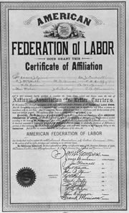
When workers are dissatisfied, they work together to make changes. These groups of workers are called unions. In 1886, a cigar workers union had a problem. The factory owners announced that they would cut wages by 20%. The workers refused to work until their wages went back to normal. This is called a strike. The workers had almost won when one small group agreed to go back to work, even with the pay cut. The strike was broken, and everyone had to go back to work or lose their jobs. The workers wanted to keep this failure from happening again, so they invited many other unions to join together.

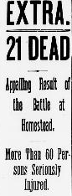
They created the American Federation of Labor, one of the oldest and most important federations of unions in the United States. Unions who join the AFL become affiliates and get certificates like the one on the right. These affiliates have access to the money and support of other unions. For example, if one union goes on strike, other affiliates may boycott that company. So many unions joined the AFL that it was powerful enough to improve safety conditions, reduce work hours, and place restrictions on child labor.

One famous strike was the Homestead Strike. Workers at Andrew Carnegie’s steel factory in Homestead, Pennsylvania went on strike in 1892. The workers refused to let anyone into the factory until the owners met their demands. On July 6th, a private security company, called the Pinkertons, tried to open the factory. The steel workers tried to stop them, and they started fighting. The state militia had to be brought in to end the strike. When Americans read the newspapers, they read headlines like the one to the right. Newspapers blamed the fighting on the strikers, not the factory owners. This caused many Americans to think unions were dangerous groups and to dislike them.

Organized Labor
- As a group, read the “Growth of Organized Labor” passage.
- Use the passage to fill in the chart that you copied.
- Choose one of the following activities to complete:
Write a 4-6 sentence newspaper article about the homestead strike. Make sure to convince people to blame the union! | Create a 5 question practice quiz and answer key about the growth of organized labor (unions). | Use an Ipad to do more research on the growth of unions in the US. Create a timeline with AT LEAST 5 events on it.
- Cigar Worker’s Union went on strike.
Effect
Cause
- Many unions join the American Federation of Labor (AFL).
- Workers and private security fight (and die) at the Homestead Strike.

