Name_____________________________________Date_______________________Block_________________
Industries of the US Chart
For each of the industries listed below, complete the chart with: a description of the industry, the city, state, and region each industry is located.
Industry | Where is this industry located? | Why was this industry important to the growth of the US? (be sure to use complete sentences in your answer).
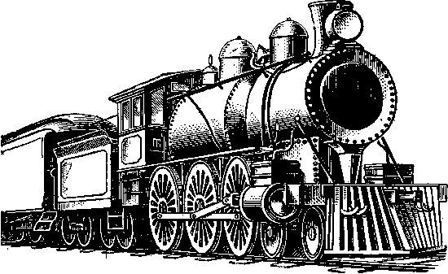
Industry: ______________
Industry: ______________
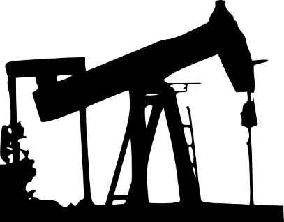
Industry: ______________
Industry: ______________
Industry: ______________
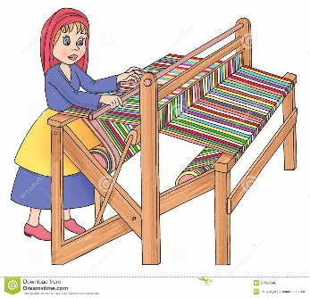
Industry: ______________
Industry: ______________

Reflection Questions
- Explain which industry you feel had the greatest impact on the development of the United States.

- Imagine you must work in one of the industries (no child labor laws!) which one would you choose and why?

- Are most industries concentrated in a certain region? If so, explain your answer.

